# Appendix

Flowcharts & Pseudocode

## 03 – generateWorld

## 04 – displayWorld

**06 – getBlockChar**

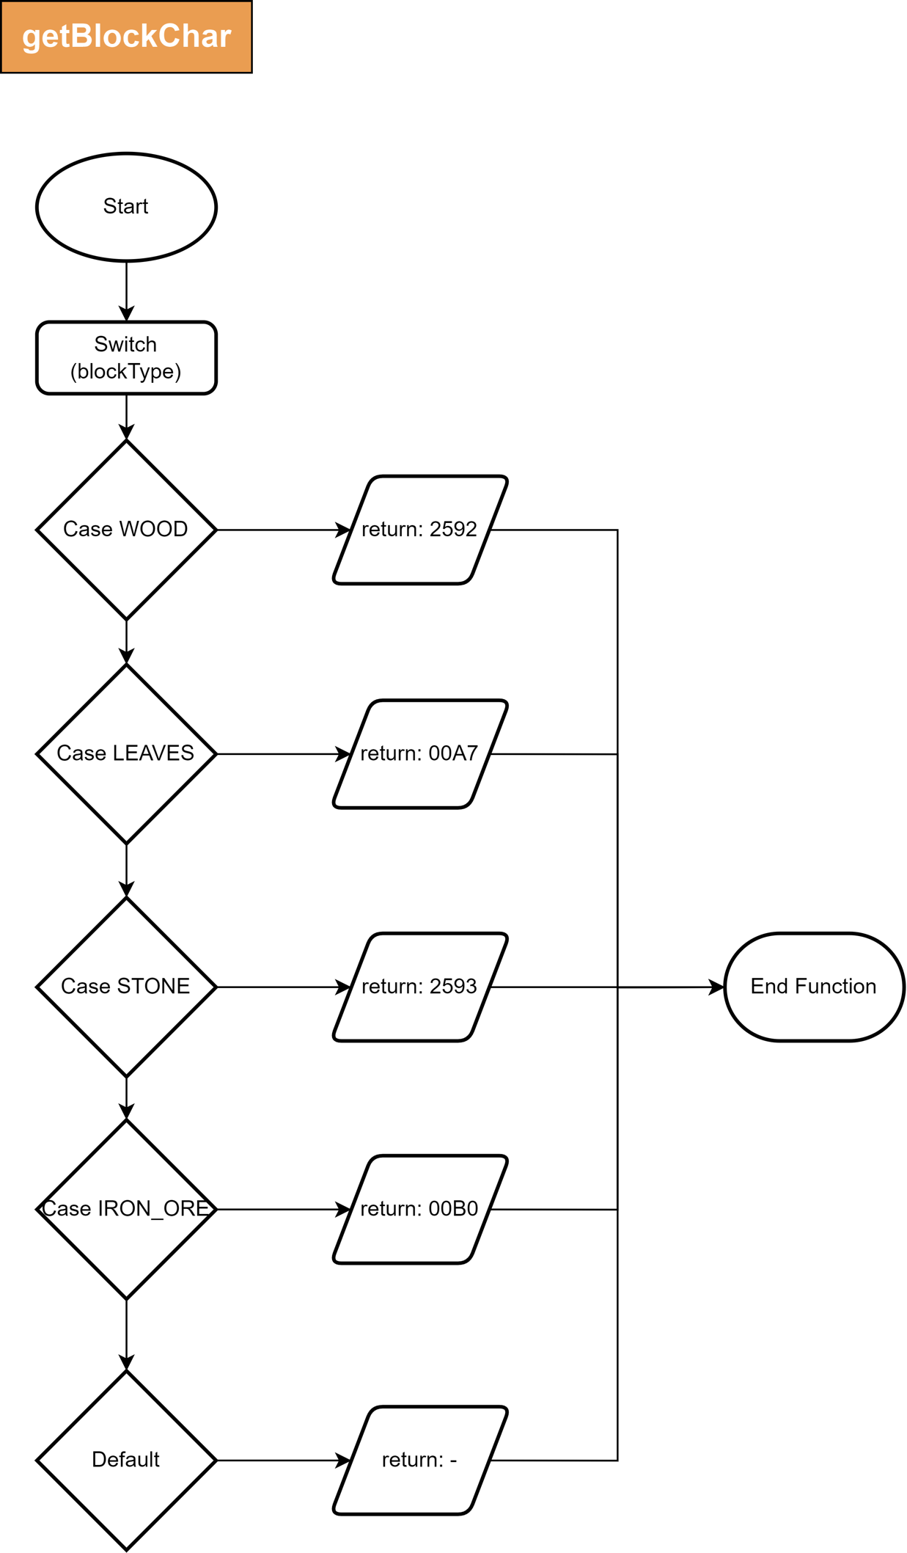

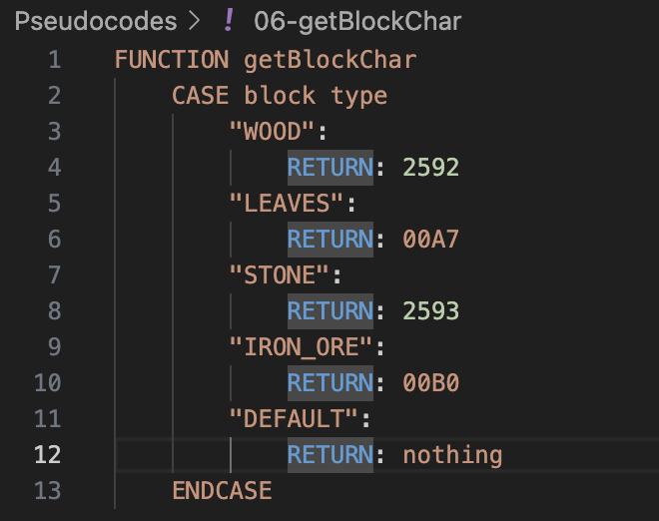

**07 – startGame**

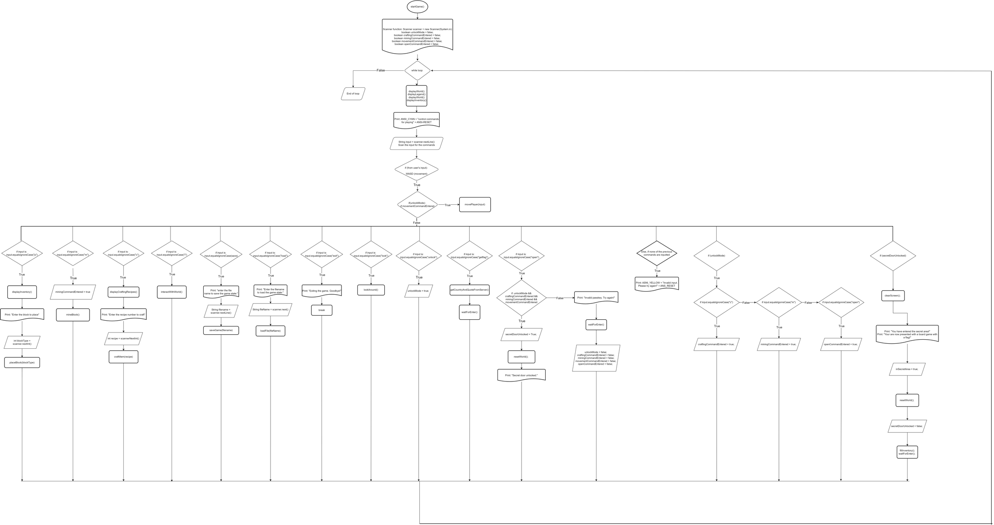

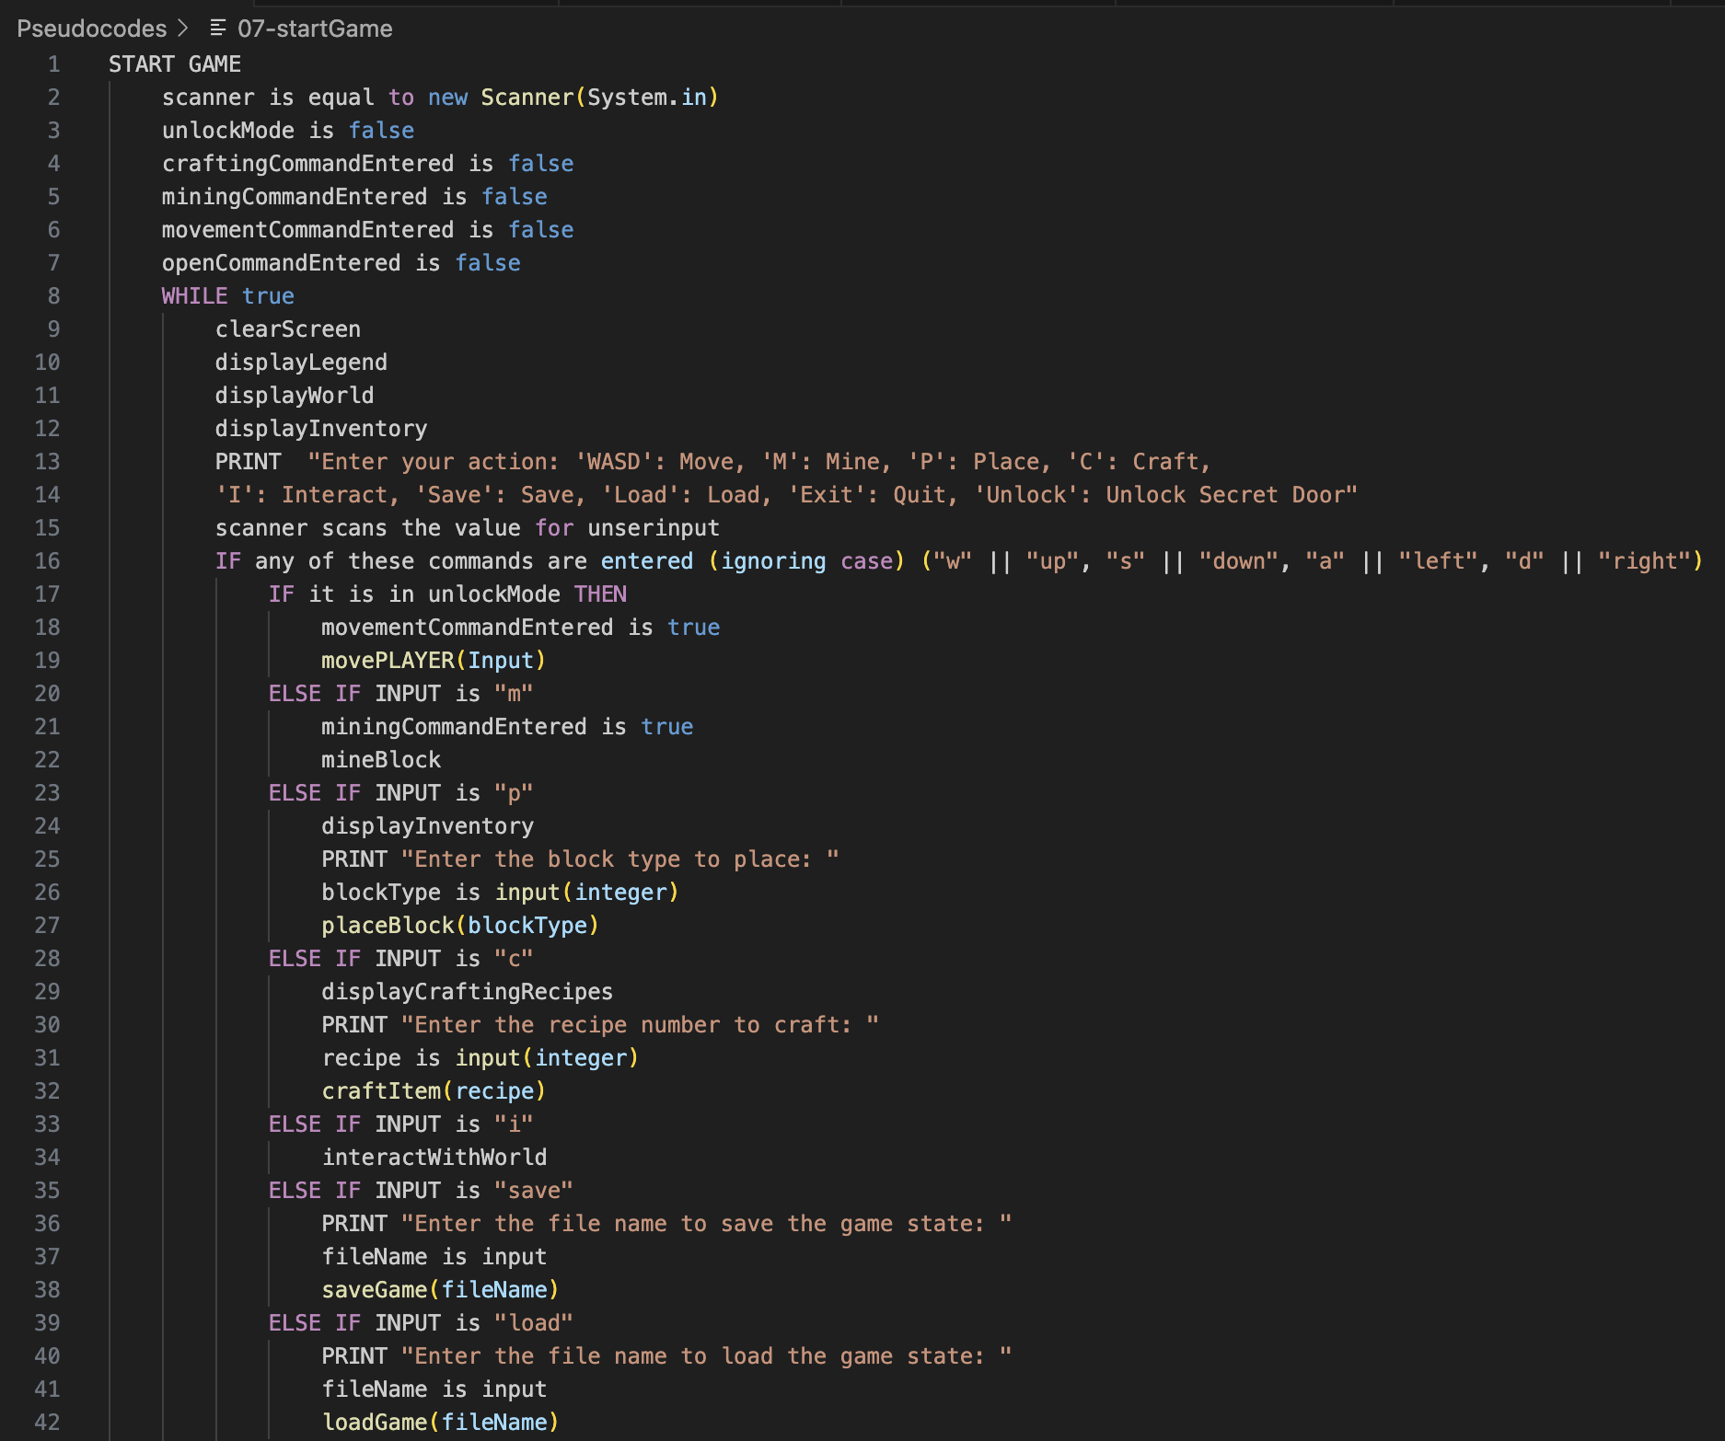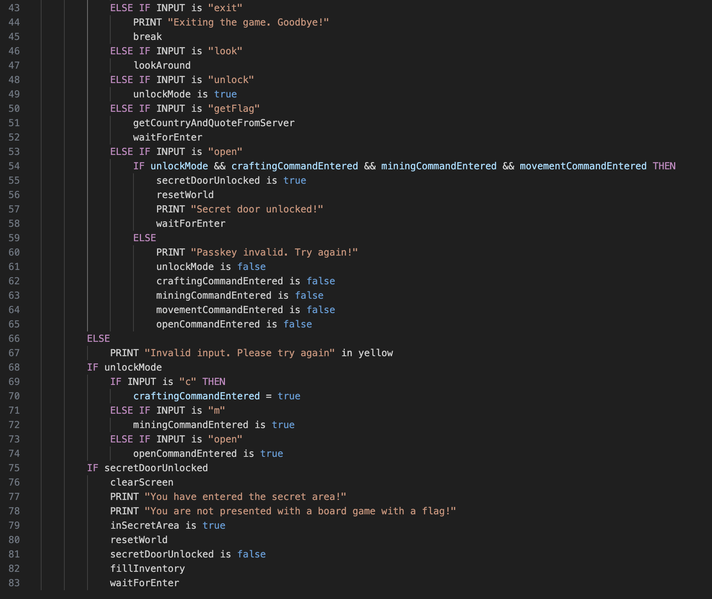

**08 – fillInventory**

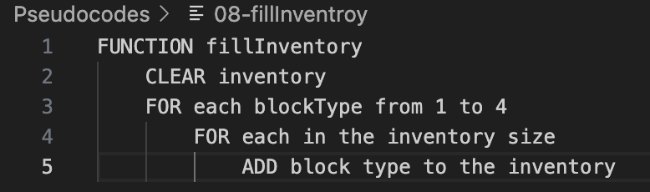

**09 – resetWorld**

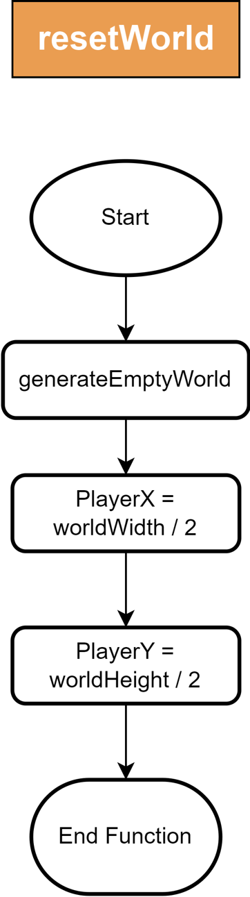

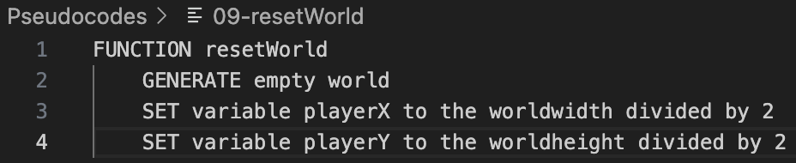

## 10 – generateEmptyWorld

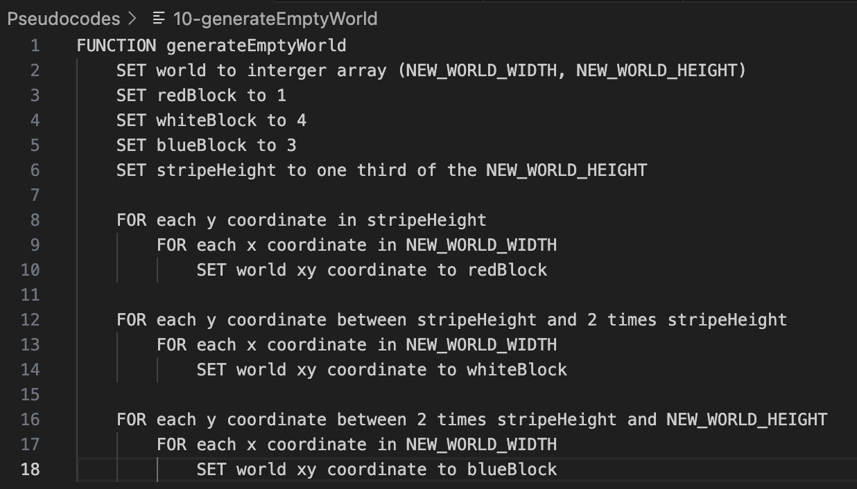

## 11 – clearScreen

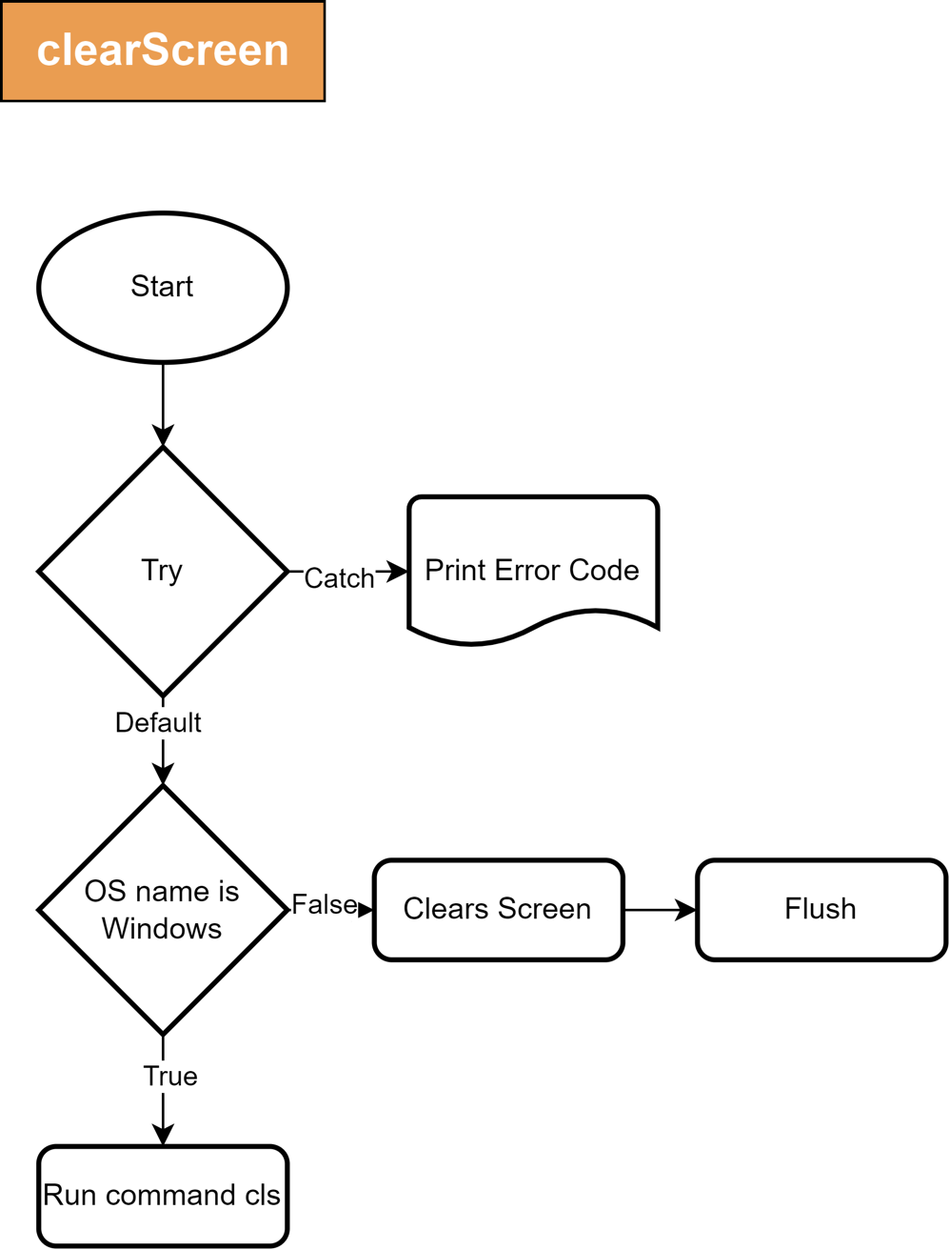

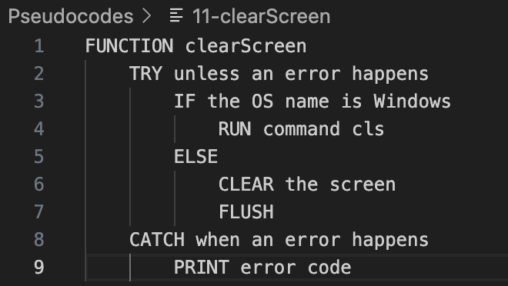

## 12 – lookAround

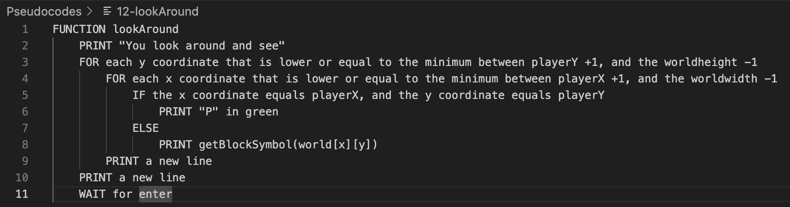

## 13 – movePlayer

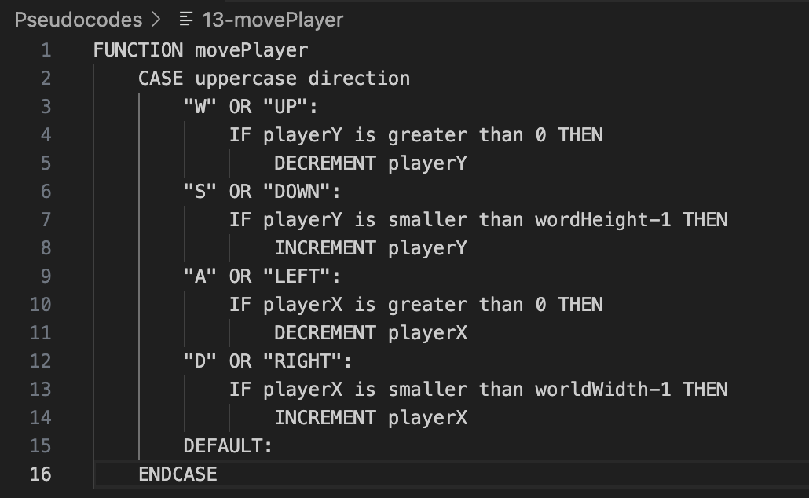

## 14 – mineBlock

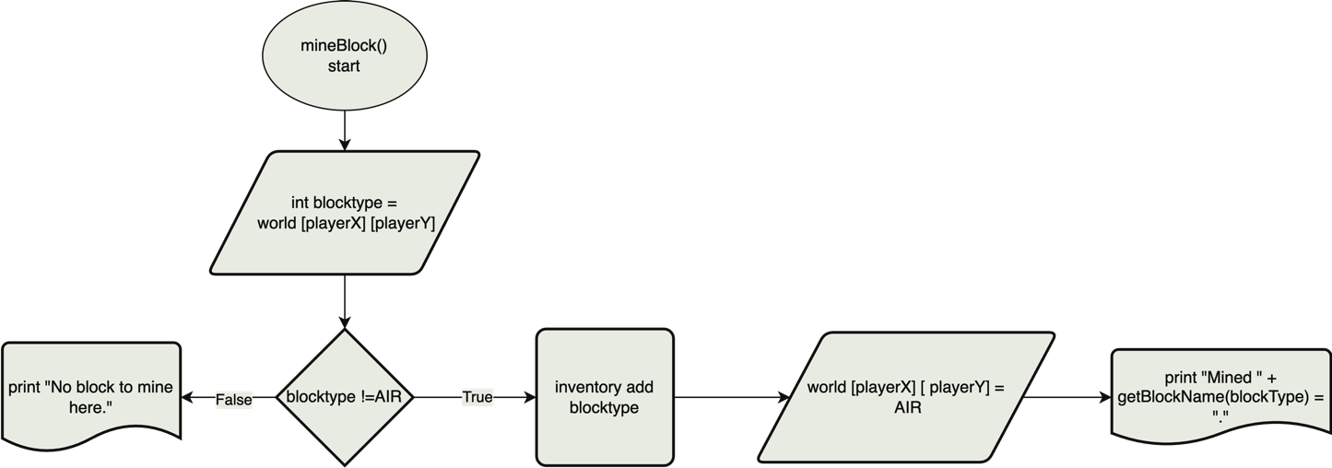

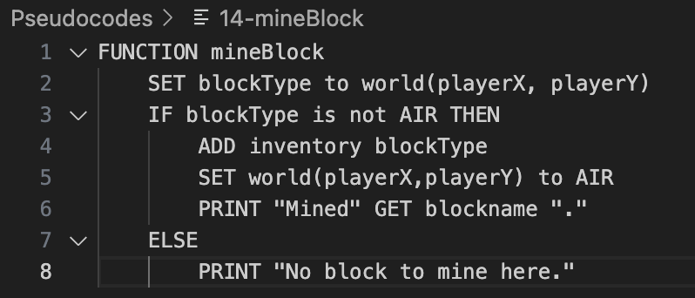

## 15 – placeBlock

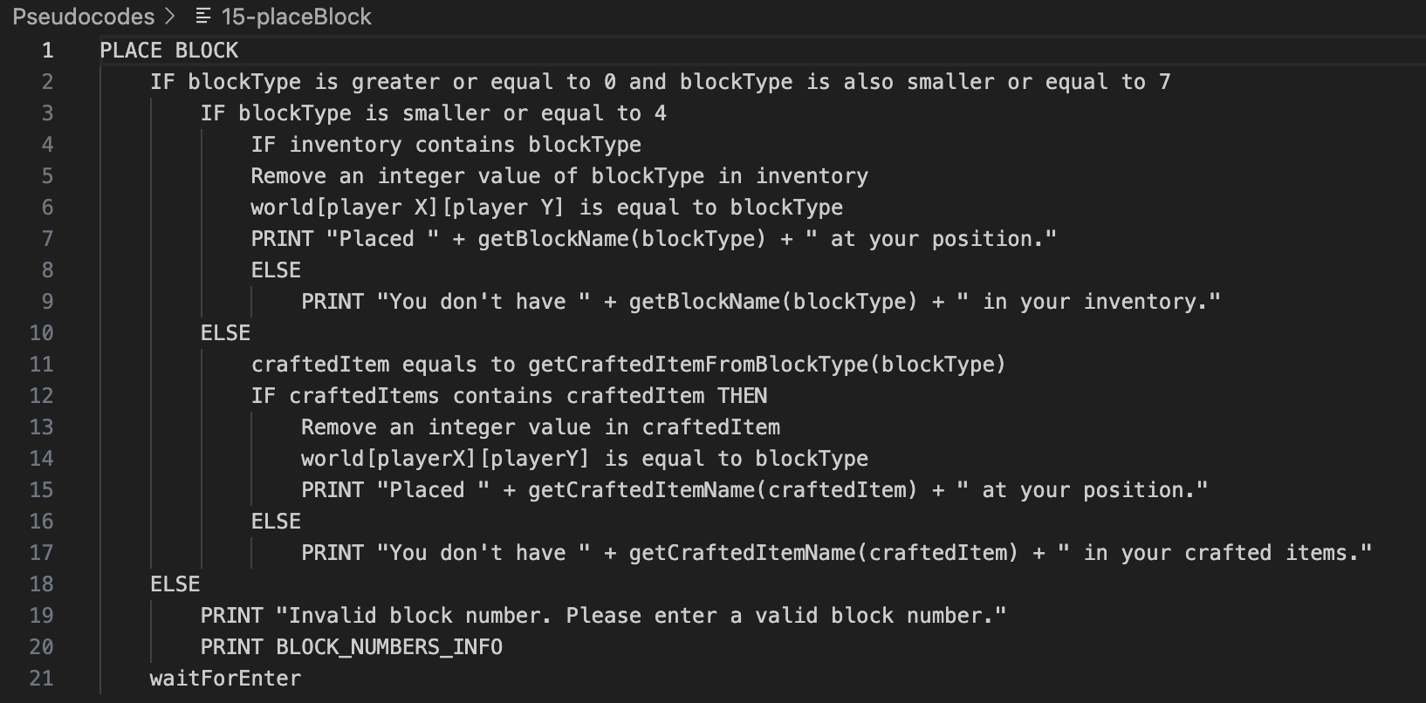

## 16 – getBlockTypeFromCraftedItem

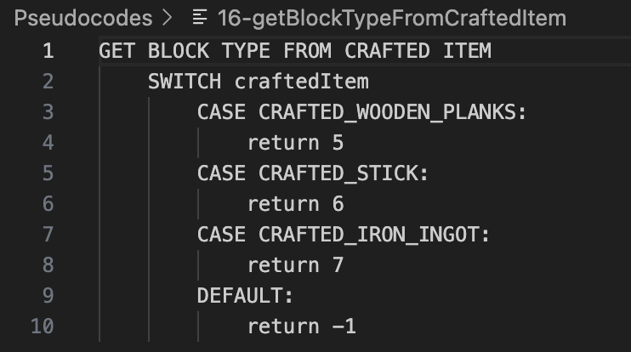

## 17 – getCraftedItemFromBlockType

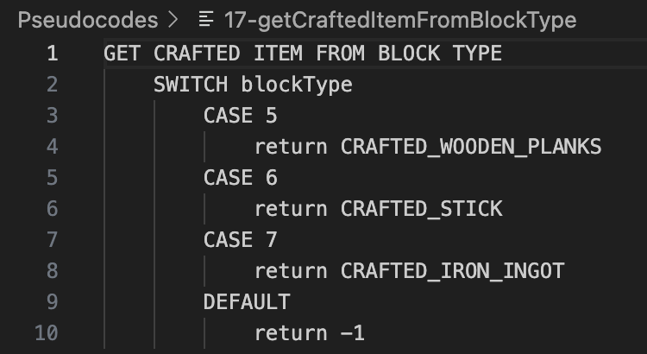

## 18 – displayCraftingRecepies

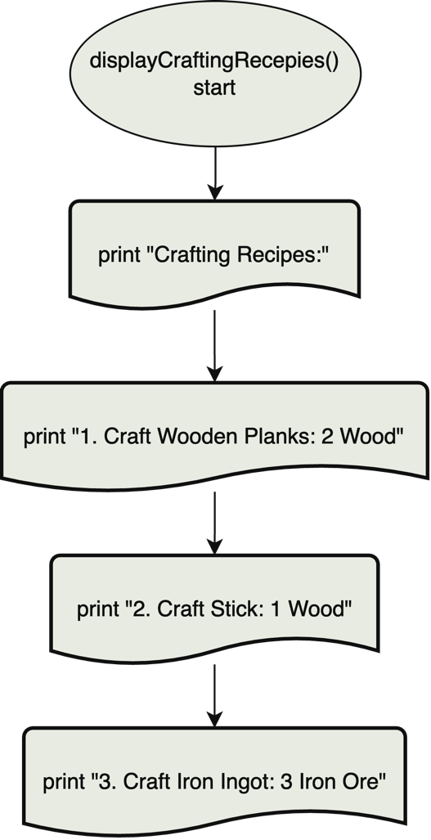

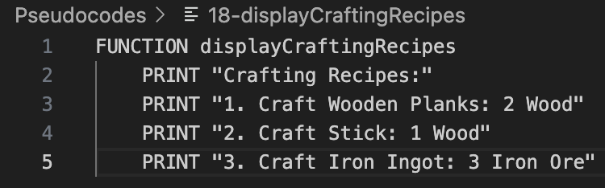

## 19 – craftItem

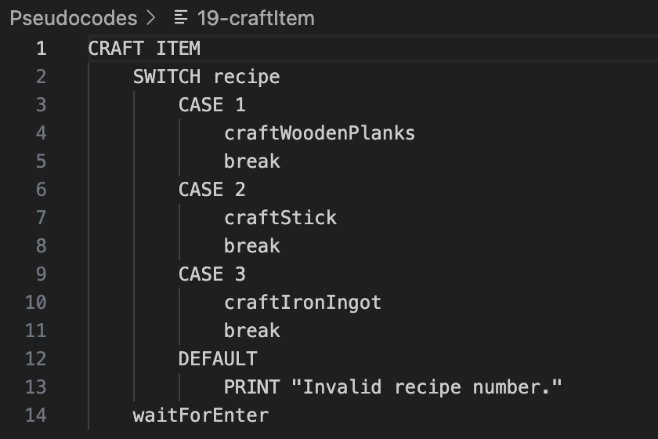

## 20 – craftWoodenPlanks

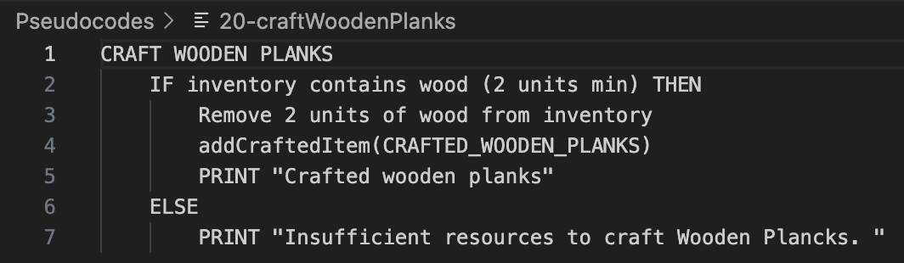

## 21 – craftStick

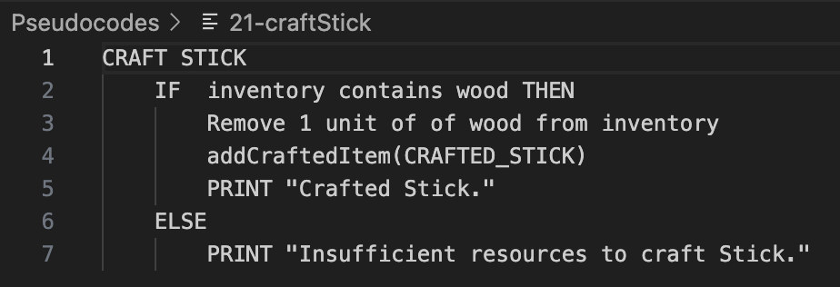

## 22 – craftIronIngot

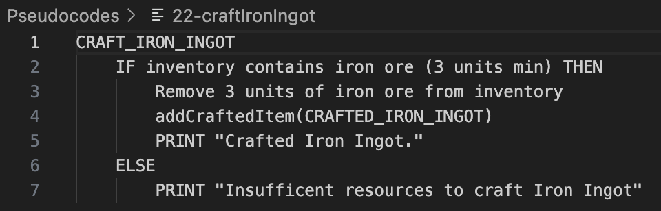

## 23-24 – inventoryContains

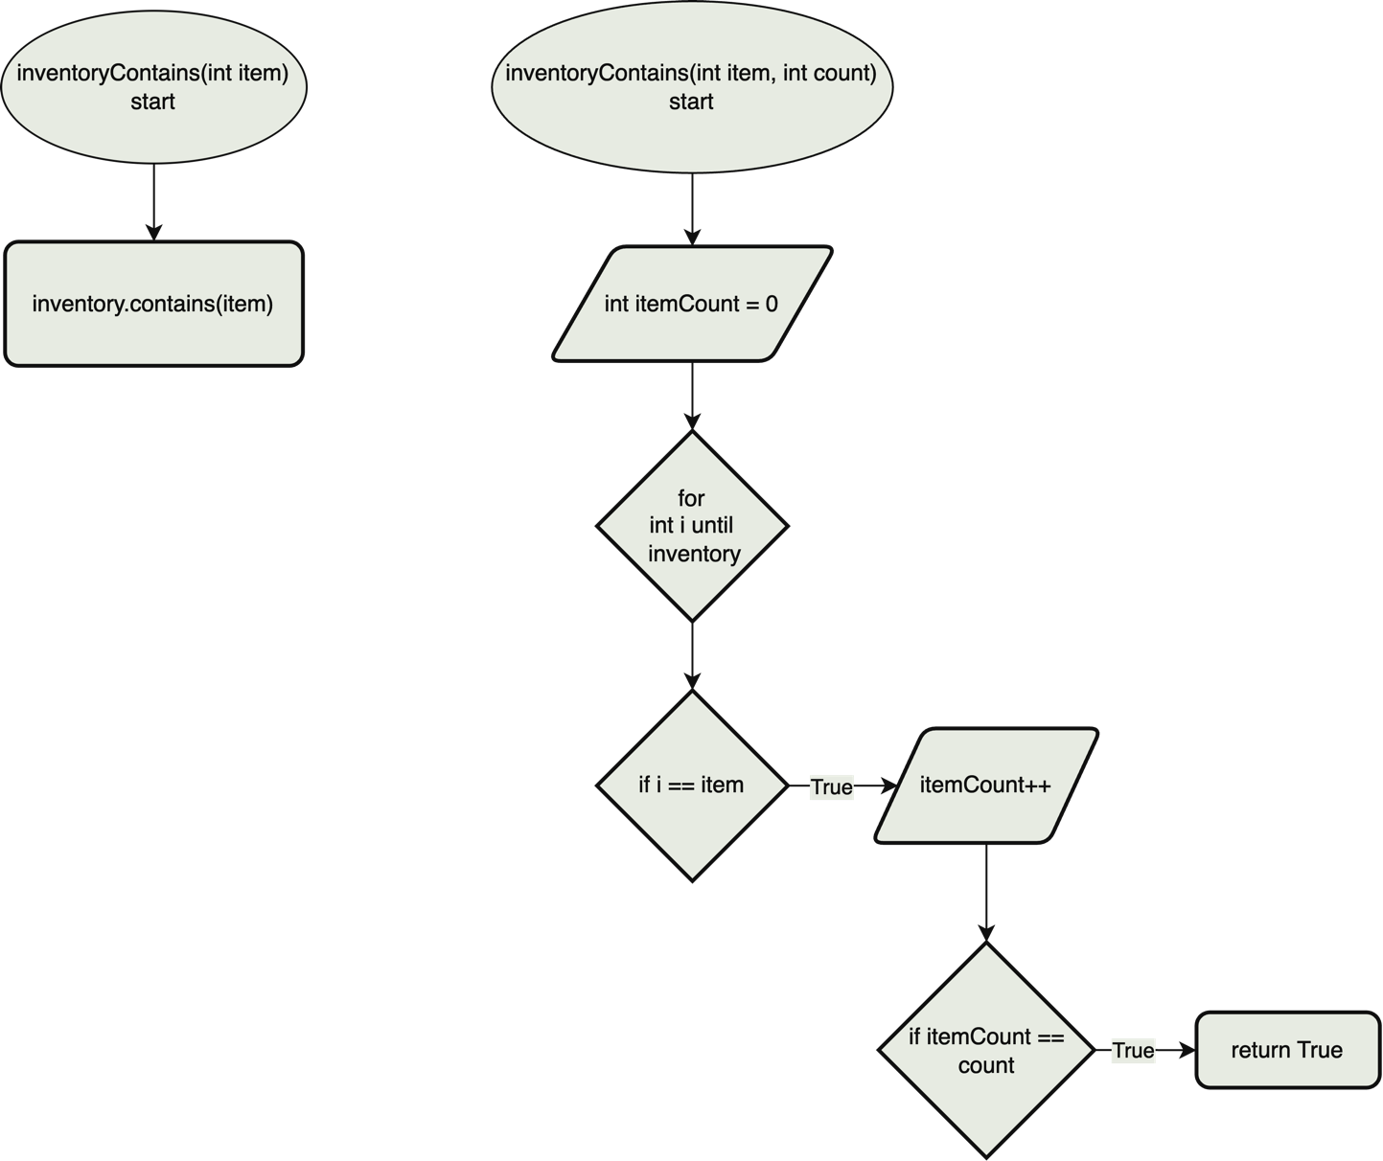

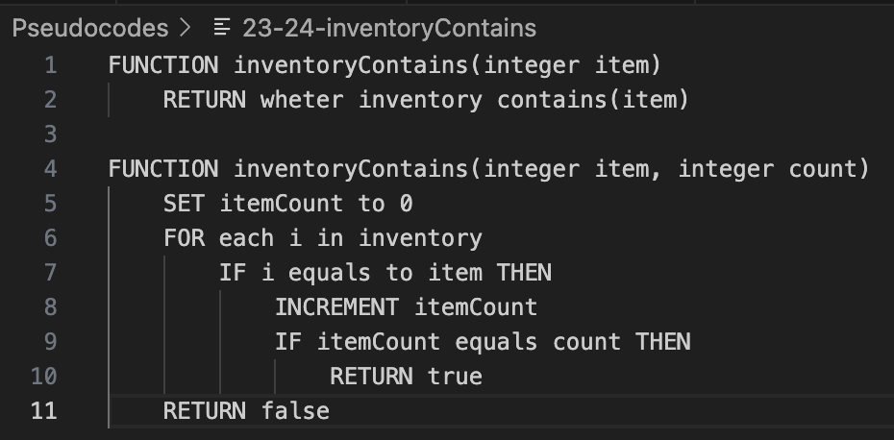

## 25 – removeItemsFromInventory

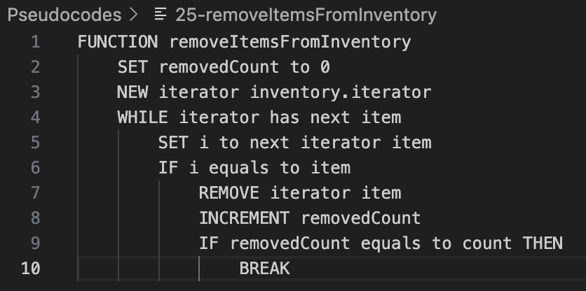

## 26 – addCraftedItem

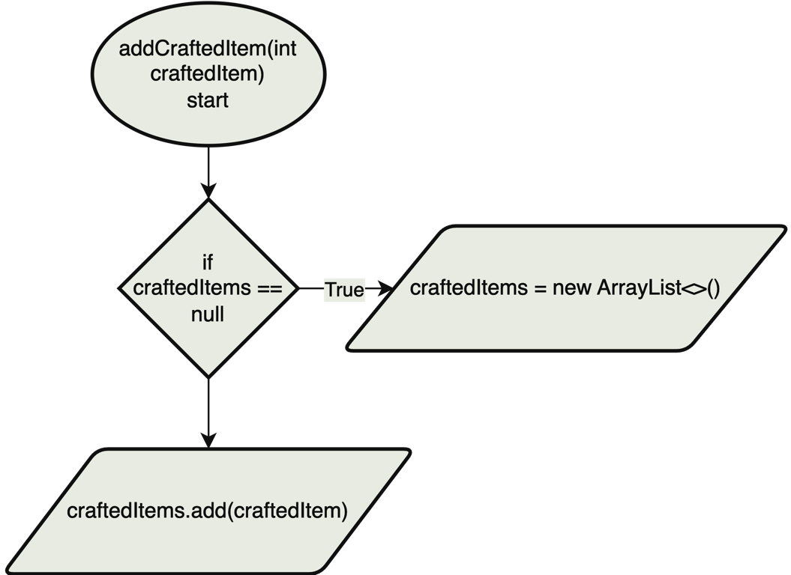

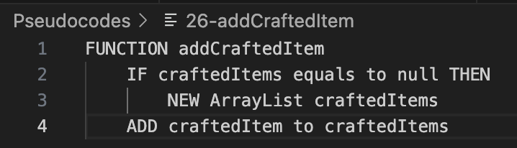

## 27 – interactWithWorld

## 28 – saveGame

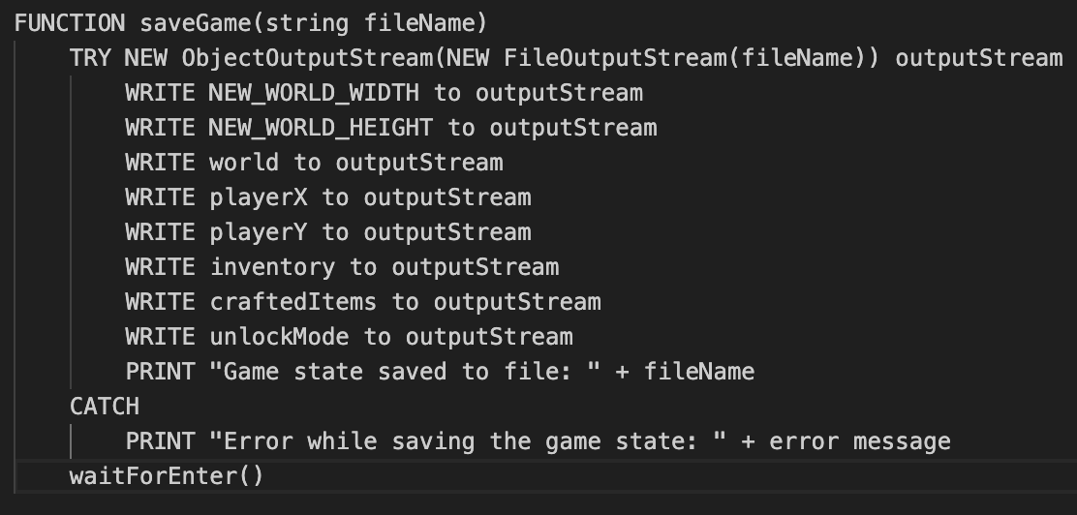

## 29 – loadGame

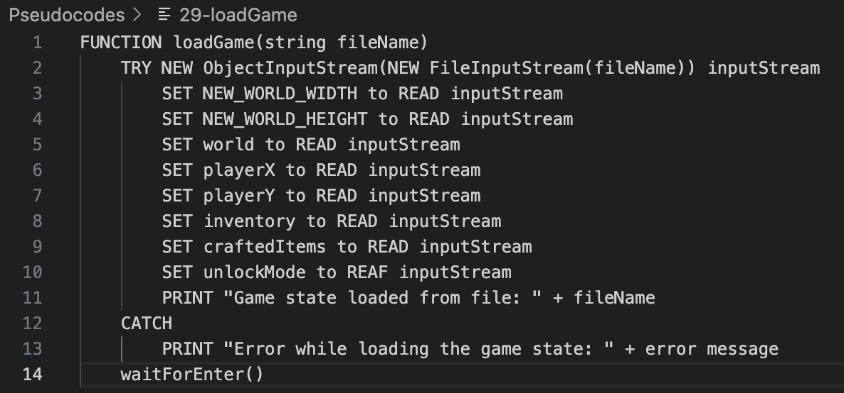

## 30 – getBlockName

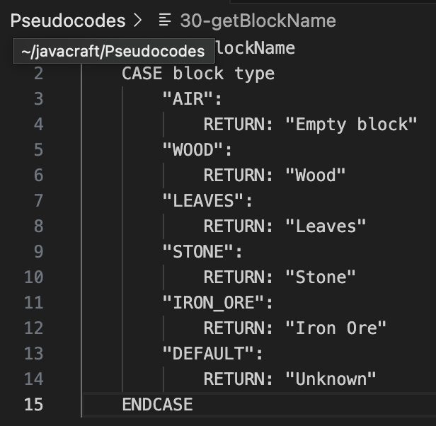

## 31 – displayLegend

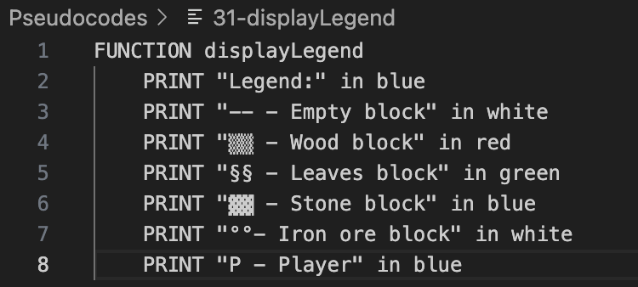

## 32 – displayInventory

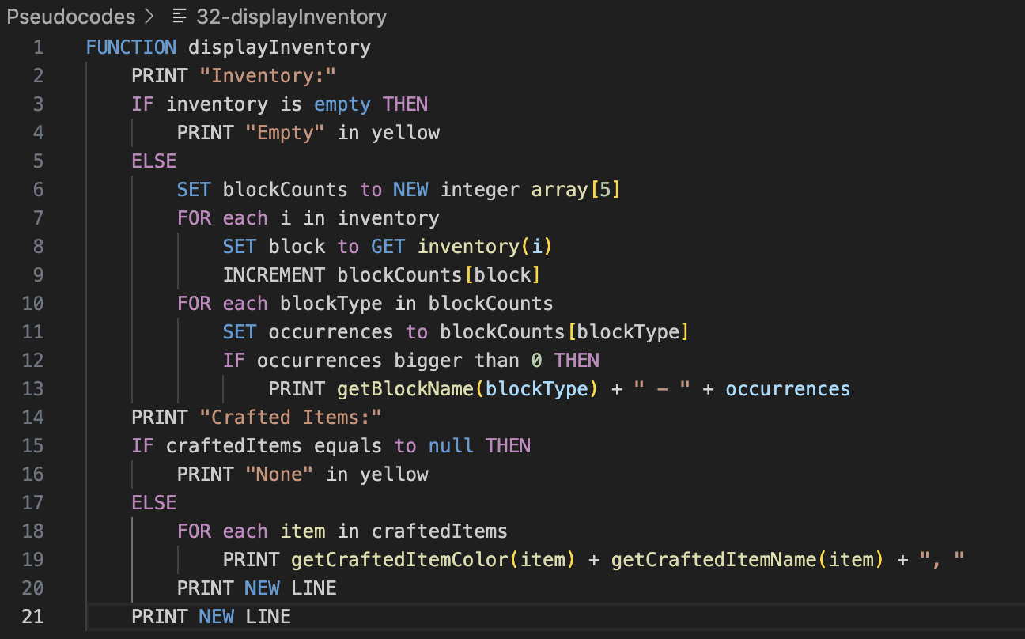

## 33 – getBlockColor

## 34 – waitForEnter

## 35 – getCraftedItemName

## 36 – getCraftedItemColor

**Flowchart for the game:**